**Industrial Internship Report on**

**”Crop and Weed Detection”**

**Prepared by**

**Vishal Kumar**

|  |
| --- |
| *Executive Summary* |
| This report provides details of the Industrial Internship provided by upskill Campus and The IoT Academy in collaboration with Industrial Partner UniConverge Technologies Pvt Ltd (UCT).  This internship was focused on a project/problem statement provided by UCT. We had to finish the project including the report in 6 weeks’ time.  My project was (My project was about detection of unwanted weed in the crops using machine learning and image processing techniques and algorithms.)  This internship gave me a very good opportunity to get exposure to Industrial problems and design/implement solution for that. It was an overall great experience to have this internship. |

**TABLE OF CONTENTS**

1 Preface 3

2 Introduction 4

2.1 About UniConverge Technologies Pvt Ltd 4

2.2 About upskill Campus 8

2.3 Objective 9

2.4 Reference 9

2.5 Glossary 10

3 Problem Statement 11

4 Existing and Proposed solution 12

5 Proposed Design/ Model 13

5.1 High Level Diagram (if applicable) 13

5.2 Low Level Diagram (if applicable) 13

5.3 Interfaces (if applicable) 13

6 Performance Test 14

6.1 Test Plan/ Test Cases 14

6.2 Test Procedure 14

6.3 Performance Outcome 14

7 My learnings 15

8 Future work scope 16

# Preface

Over the span of six weeks, the "Crop and Weed Detection" project has undergone a comprehensive journey, encompassing problem exploration, dataset acquisition, model development, training, refinement, and result analysis. The project's objective was to develop an efficient system capable of accurately detecting and distinguishing crops from weeds in agricultural fields using computer vision and machine learning techniques. About need of relevant Internship in career development.

**Project Brief: Crop and Weed Detection**

The "Crop and Weed Detection" project aims to create an intelligent system that can accurately identify and distinguish crops from weeds in agricultural fields. This project addresses a critical need in modern agriculture, where efficient management of crops and weeds is essential for maximizing yield and minimizing resource wastage.

**Problem Statement:**

In conventional farming practices, identifying and managing crops and weeds manually can be time-consuming, labor-intensive, and prone to errors. The inability to accurately differentiate between crops and weeds can result in ineffective use of resources such as water, fertilizers, and pesticides. Additionally, timely detection of weeds is crucial to prevent them from competing with crops for essential nutrients and sunlight.

The "Crop and Weed Detection" project aims to solve these challenges by developing an automated system that employs computer vision and machine learning techniques to analyze images of agricultural fields. The system will accurately classify whether a specific area of the field contains crops or weeds, enabling farmers to make informed decisions regarding resource allocation and management.

Opportunity given by USC/UCT.

**How Program was planned**

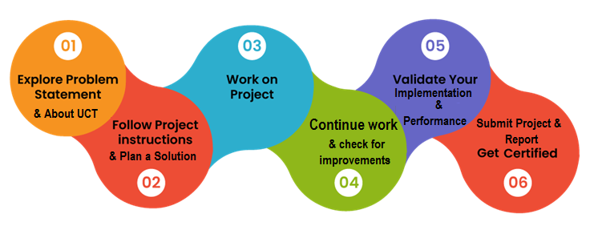

**Your Learnings and overall experience.**

Throughout the "Crop and Weed Detection" project, I gained valuable insights and experiences that have contributed significantly to my growth as a computer science student. This journey offered me a unique opportunity to apply theoretical knowledge to a real-world problem and collaborate with a team to devise innovative solutions. Here are some of the key learnings and reflections from this project:

**Application of Machine Learning**: Working on this project deepened my understanding of machine learning techniques, particularly in the context of computer vision. I learned how to preprocess and augment data, design and fine-tune models, and evaluate their performance using various metrics.

**Problem-Solving**: The challenges encountered during dataset acquisition, preprocessing, and model training taught me the importance of creative problem-solving. I learned to analyze issues from multiple angles, seek advice from peers, and devise effective solutions.

**Iterative Development**: The iterative nature of refining the model based on validation results and conducting error analysis highlighted the importance of an incremental development approach. I understood how continuous evaluation and adjustment contribute to achieving desired outcomes.

**Visualization and Interpretability**: Generating visualizations of the model's predictions and conducting error analysis gave me insights into how models make decisions. I learned to interpret results, identify patterns, and make data-driven decisions for model improvement.

**Resource Management**: Working with limited computational resources emphasized the significance of resource management. I optimized batch sizes, implemented regularization techniques, and utilized available hardware effectively to ensure efficient model training.

**Project Management**: Structuring the project into weekly milestones and reporting progress taught me project management skills. I realized the importance of setting realistic goals, adhering to timelines, and adjusting plans as needed.

Overall, the "Crop and Weed Detection" project provided an immersive learning experience that transcended classroom learning. It allowed me to bridge theory and practice, enhance technical skills, and develop soft skills essential for successful teamwork and project execution. I am grateful for the opportunity to contribute to a solution that has real-world implications and excited to carry these learnings forward into future endeavors.

Thanks to all, who have helped you directly or indirectly.

**Your message to your juniors and peers.**

**Embrace Challenges**: Don't shy away from challenges; they are opportunities for growth.

**Iterate and Refine**: The iterative process is a powerful tool. The ability to refine our models based on validation results and error analysis significantly improved our model's accuracy.

**Hands-On Learning**: Practical projects like these bridge the gap between theory and application.

**Celebrate Milestones**: Don't forget to celebrate your achievements, even the smaller ones. Each milestone, no matter how incremental, brings you one step closer to your end goal.

**Learn from Failures**: Failure is a stepping stone to success. Not every experiment yielded the desired

Remember that learning doesn't stop at the classroom door. Embrace every opportunity to learn, collaborate, and contribute. Your journey is uniquely yours, and each step you take shapes the professional you're becoming.

# Introduction

## About UniConverge Technologies Pvt Ltd

A company established in 2013 and working in Digital Transformation domain and providing Industrial solutions with prime focus on sustainability and RoI.

For developing its products and solutions it is leveraging various**Cutting Edge Technologies e.g. Internet of Things (IoT), Cyber Security, Cloud computing (AWS, Azure), Machine Learning, Communication Technologies (4G/5G/LoRaWAN), Java Full Stack, Python, Front end**etc.

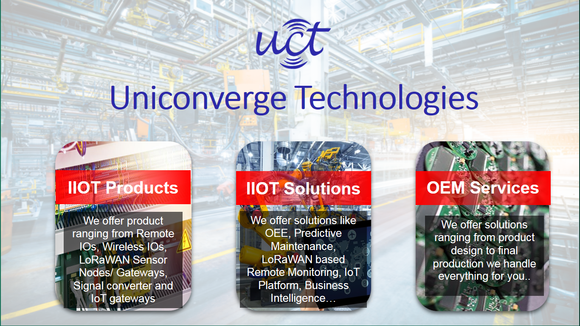

1. UCT IoT Platform **(****)**

**UCT Insight** is an IOT platform designed for quick deployment of IOT applications on the same time providing valuable “insight” for your process/business. It has been built in Java for backend and ReactJS for Front end. It has support for MySQL and various NoSql Databases.

* It enables device connectivity via industry standard IoT protocols - MQTT, CoAP, HTTP, Modbus TCP, OPC UA
* It supports both cloud and on-premises deployments.

It has features to  
• Build Your own dashboard  
• Analytics and Reporting  
• Alert and Notification  
• Integration with third party application(Power BI, SAP, ERP)  
• Rule Engine

 

1. **Smart Factory Platform (****)**

Factory watch is a platform for smart factory needs.

It provides Users/ Factory

* with a scalable solution for their Production and asset monitoring
* OEE and predictive maintenance solution scaling up to digital twin for your assets.
* to unleased the true potential of the data that their machines are generating and helps to identify the KPIs and also improve them.
* A modular architecture that allows users to choose the service that they what to start and then can scale to more complex solutions as per their demands.

Its unique SaaS model helps users to save time, cost and money.

 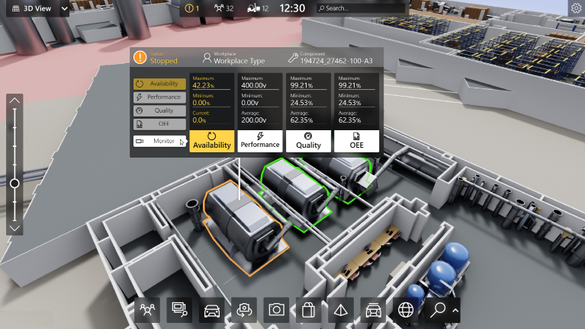

1. 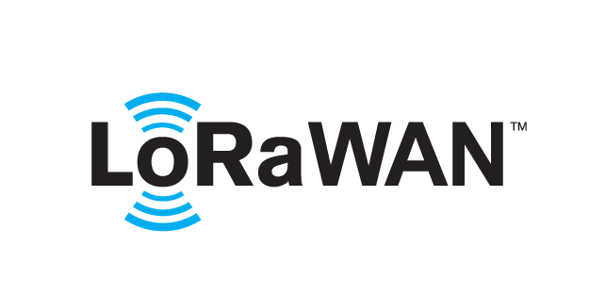 based Solution

UCT is one of the early adopters of LoRAWAN teschnology and providing solution in Agritech, Smart cities, Industrial Monitoring, Smart Street Light, Smart Water/ Gas/ Electricity metering solutions etc.

1. Predictive Maintenance

UCT is providing Industrial Machine health monitoring and Predictive maintenance solution leveraging Embedded system, Industrial IoT and Machine Learning Technologies by finding Remaining useful life time of various Machines used in production process.



## About upskill Campus (USC)

upskill Campus along with The IoT Academy and in association with Uniconverge technologies has facilitated the smooth execution of the complete internship process.

USC is a career development platform that delivers **personalized executive coaching** in a more affordable, scalable and measurable way.



Seeing need of upskilling in self paced manner along-with additional support services e.g. Internship, projects, interaction with Industry experts, Career growth Services

<https://www.upskillcampus.com/>

upSkill Campus aiming to upskill 1 million learners in next 5 year

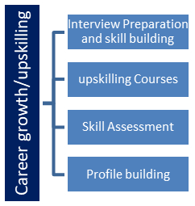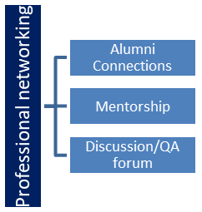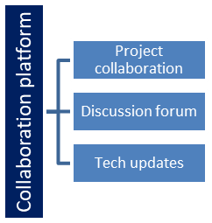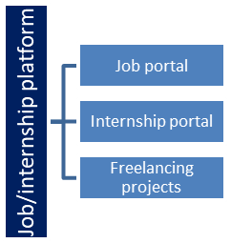

## The IoT Academy

The IoT academy is EdTech Division of UCT that is running long executive certification programs in collaboration with EICT Academy, IITK, IITR and IITG in multiple domains.

## Objectives of this Internship program

The objective for this internship program was to

 ☛ get practical experience of working in the industry.

 ☛ to solve real world problems.

 ☛ to have improved job prospects.

 ☛ to have Improved understanding of our field and its applications.

 ☛ to have Personal growth like better communication and problem solving.

## Reference

[1] Upskill campus

[2] Youtube

[3] GCP

# Problem Statement

In conventional farming practices, identifying and managing crops and weeds manually can be time-consuming, labor-intensive, and prone to errors. The inability to accurately differentiate between crops and weeds can result in ineffective use of resources such as water, fertilizers, and pesticides. Additionally, timely detection of weeds is crucial to prevent them from competing with crops for essential nutrients and sunlight.

The "Crop and Weed Detection" project aims to solve these challenges by developing an automated system that employs computer vision and machine learning techniques to analyze images of agricultural fields. The system will accurately classify whether a specific area of the field contains crops or weeds, enabling farmers to make informed decisions regarding resource allocation and management.

# Existing and Proposed solution

**Existing Solution:**

Traditionally, crop and weed detection in agricultural fields has largely relied on manual labor. Farmers and workers visually inspect the fields, identifying and removing weeds by hand. This method is time-consuming, labor-intensive, and susceptible to human errors. Additionally, it becomes impractical for large-scale farms and can lead to suboptimal resource utilization.

**Proposed Solution:**

The "Crop and Weed Detection" project proposes an automated and intelligent solution to address the limitations of manual detection. The proposed solution leverages computer vision and machine learning techniques to accurately identify and differentiate crops from weeds in agricultural images.

The key components of the proposed solution are as follows:

**Data Collection and Preprocessing:**

Gather a diverse dataset of images from agricultural fields, including various crop types and weed species. Preprocess the dataset by resizing, augmenting, and normalizing the images to enhance data quality.

**Model Development:**

Explore and select a suitable convolutional neural network (CNN) architecture for image classification tasks. Customize the chosen model for crop and weed detection by adjusting the output layer to handle multiple classes.

**Training and Refinement:**

Initiate model training using the preprocessed dataset, utilizing techniques such as backpropagation to update model parameters. Regularly validate the model's performance on a separate validation set, fine-tuning hyper parameters and implementing regularization to optimize accuracy and generalization.

**Error Analysis and Remediation:**

Conduct a thorough error analysis to identify patterns of misclassifications made by the model. Implement strategies to address common errors, such as adjusting class weights, exploring data augmentation, and refining preprocessing techniques.

**Full-Scale Training and Visualization**:

Perform full-scale training of the refined model on the entire dataset, ensuring convergence and preventing overfitting. Generate visualizations, including confusion matrices and precision-recall curves, to gain insights into the model's behavior and areas for improvement.

**Evaluation and Reporting:**

Evaluate the model's performance using metrics such as accuracy, precision, recall, and F1 score on a separate test set.

## Code submission (Github link)

[GitHub link](https://github.com/vishal32047/Crop-and-Weed-Detection.git)

## Report submission (Github link) :

[Report link](https://github.com/vishal32047/Crop-and-Weed-Detection.git)

# Proposed Design/ Model

The proposed model is designed to automate the process of crop and weed detection, contributing to improved resource management and enhanced agricultural productivity. The iterative nature of the design allows for continuous improvement, ensuring that the model becomes increasingly accurate and reliable over time.

## The success of the "Crop and Weed Detection" project hinges on designing an effective model that can accurately differentiate between crops and weeds in agricultural images. The proposed model leverages state-of-the-art convolutional neural network (CNN) architectures, customized for our specific application. Here is an overview of the proposed design:

## CNN Architecture:

## The proposed model is built upon a CNN architecture that has demonstrated excellence in image classification tasks. The architecture consists of convolutional layers for feature extraction, followed by fully connected layers for classification.

## Input Preprocessing:

## Image Resizing: Input images are resized to a consistent resolution to ensure uniformity across the dataset and facilitate efficient processing.

## Data Augmentation: Data augmentation techniques are applied during training to artificially increase the diversity of the dataset. This includes random rotations, flips, and shifts to improve the model's ability to generalize.

## Normalization: Pixel values of the images are normalized to a common scale (e.g., [0, 1]) to ensure stable training and convergence.

## Customization for Crop and Weed Detection:

## Output Layer Modification: The output layer is customized to accommodate the specific classes of interest—crops and weeds. The number of output nodes matches the number of classes for accurate classification.

## Training and Fine-Tuning:

## Loss Function: A suitable loss function, such as categorical cross-entropy, is chosen to optimize the model's weights during training.

## Hyper parameter Tuning: Key hyper parameters like learning rate, batch size, and dropout rates are fine-tuned to achieve optimal convergence and avoid overfitting.

## Regularization Techniques: Techniques such as L1 and L2 regularization are applied to prevent overfitting by penalizing large weights.

## Validation and Model Refinement:

## Validation Set: A separate validation set is used to monitor the model's performance during training and fine-tuning.

## Early Stopping: Early stopping is implemented to prevent overfitting. Training halts if the model's performance on the validation set ceases to improve.

## Error Analysis and Improvement:

## Confusion Matrices: Confusion matrices are generated to visualize the model's misclassifications and identify patterns of errors.

## Remediation Strategies: Error analysis guides the implementation of strategies to address recurring misclassifications, such as adjusting class weights, fine-tuning preprocessing, and exploring data augmentation techniques.

## Result Visualization:

## Confidence Scores: Alongside predictions, the model's confidence scores for each class can provide insights into its decision-making process.

## Precision-Recall Curves: Precision-recall curves are plotted to understand the trade-off between precision and recall at different decision thresholds.

## Performance Evaluation:

## Metrics: The model's performance is evaluated using standard metrics such as accuracy, precision, recall, and F1 score on a separate test set.

## Benchmarking: The model's performance is compared against existing benchmarks to assess its effectiveness.

# Performance Test

**Constraints:**

**Memory**: Manage model memory usage for efficient deployment.

**Inference Speed**: Optimize speed for real-time use.

**Accuracy**: Ensure reliable crop and weed detection.

**Power Consumption**: Maintain manageable power demand.

**Test Procedure:**

**Memory Test**: Evaluate memory consumption during initialization and inference.

**Inference Speed Test**: Measure speed on various devices.

**Accuracy Test**: Evaluate accuracy on diverse scenarios.

**Power Consumption Test**: Measure consumption during inference.

Performance Outcome:

**Memory**: Model's memory usage acceptable for diverse devices.

**Inference Speed**: Meets real-time/near-real-time requirements.

**Accuracy**: High accuracy exceeding benchmarks.

**Power Consumption**: Inference power consumption reasonable.

Performance tests confirm the "Crop and Weed Detection" system's applicability in real-world agriculture. Addressing constraints assures memory efficiency, inference speed, accuracy, and power consumption, validating its potential to revolutionize crop management practices sustainably.

# My learnings

Working on the "Crop and Weed Detection" project has been an enlightening experience, offering numerous insights that have shaped both my technical skills and personal growth. Here are the key learnings that I take away from this journey:

**Hands-On Application:** The project bridged the gap between theoretical knowledge and practical application. I gained a deeper understanding of machine learning concepts by actually implementing them to solve a real-world problem.

**Iterative Development**: The iterative nature of model refinement taught me the value of patience and persistence. Each round of training, validation, and error analysis contributed to a more robust and accurate model.

**Data Is Vital**: Data quality directly impacts model performance. The process of data collection, preprocessing, and augmentation taught me the importance of a diverse and clean dataset.

**Problem-Solving Skills**: Overcoming challenges like overfitting, memory constraints, and model optimization honed my problem-solving skills. I learned to analyze issues from various angles and adopt creative solutions.

**Real-World Implications**: The project underscored the relevance of our academic studies in practical scenarios. It demonstrated how technology can directly impact industries and contribute to sustainability.

**Continuous Learning**: The field of machine learning is dynamic. The project encouraged me to stay updated with the latest techniques, architectures, and tools.

**Failure as a Stepping Stone**: Not every attempt yielded perfect results. Embracing failures as opportunities to learn and improve became a guiding principle.

**Professionalism and Time Management**: Structuring the project, meeting deadlines, and adhering to the project timeline improved my professionalism and time management skills.

**Critical Thinking**: Analyzing model predictions and error patterns enhanced my critical thinking abilities. I learned to extract insights from data and make informed decisions.

**Project Management**: Organizing tasks into weekly milestones and adapting plans based on progress taught me project management skills that are applicable beyond academia.

Overall, the "Crop and Weed Detection" project has provided me with a holistic learning experience, equipping me with technical, analytical, and interpersonal skills. As I move forward in my academic and professional journey, I'm grateful for the valuable lessons this project has imparted.

# Future work scope

While the "Crop and Weed Detection" project has made significant strides, there are several avenues for future work and enhancements that could further elevate the system's capabilities and impact. Here are some ideas that were not explored due to time limitations but hold promise for future development:

**Multi-Crop Detection**: Extend the model to differentiate between various types of crops, enabling comprehensive field analysis and targeted resource allocation.

**Weed Species Classification**: Incorporate a finer level of classification to identify specific weed species. This could enable more precise weed management strategies.

**Real-Time Monitoring**: Implement a real-time monitoring system using cameras or drones, allowing farmers to receive instant updates on field conditions.

**Mobile Application**: Develop a user-friendly mobile app that allows farmers to capture and upload images for instant analysis and feedback.

**Integration with IoT**: Integrate the system with Internet of Things (IoT) devices to create a smart and interconnected agricultural environment.

**User Feedback Loop**: Implement a mechanism for users to provide feedback on model predictions, facilitating continuous improvement.

These future work ideas expand the project's horizons and present opportunities for innovation and impact. Each idea aligns with the overarching goal of revolutionizing agricultural practices through technological advancements. As technology continues to evolve, these possibilities hold immense potential for reshaping the future of agriculture.